Global E-commerce Sales Analysis
Problem Statement
The objective of this project is to analyze global e-commerce sales data to understand sales performance, profitability, customer behavior, product performance, regional trends, payment methods, discount impact, and shipping costs. The analysis helps identify top-performing products and categories, profitable regions and customer segments, and areas where business performance can be improved.
Project Objectives
- Analyze overall sales and profit performance.
- Identify the best-performing products and product categories.
- Analyze sales and profit by region and country.
- Understand customer segment performance.
- Analyze payment method usage.
- Study monthly sales trends.
- Understand the impact of discounts on profit.
- Analyze shipping costs by region.
- Create an interactive Power BI dashboard.
- Use Python for additional data analysis and visualization.
Dataset Description
The dataset contains 2,000 global e-commerce sales records covering the period from 2023 to 2025. It includes information about orders, customers, products, sales, discounts, shipping costs, profits, regions, countries, and payment methods.
Number of Records: 2,000
Number of Columns: 15
Data Period: 2023-2025
Tools Used
- Microsoft Excel – Data preparation, cleaning, pivot tables, and initial analysis.
- MySQL – Data storage and SQL-based analysis.
- Power BI – Interactive dashboard and data visualization.
- Python (Pandas & Matplotlib) – Data analysis and visualization.
- Microsoft Word – Project documentation.
Methodology
- Data Preparation – Reviewed and prepared the e-commerce dataset in Microsoft Excel.
- Data Cleaning – Checked data types, missing values, duplicate records, and date formats.
- Excel Analysis – Created pivot tables and charts to analyze sales, profit, products, customers, regions, discounts, and shipping costs.
- SQL Analysis – Imported the data into MySQL and used SQL queries to calculate key business metrics and performance indicators.
- Power BI Visualization – Created an interactive dashboard to present important sales and profit insights.
- Python Analysis – Used Pandas for data analysis and Matplotlib for additional visualizations.
- Insights and Recommendations – Identified important business trends and areas for improvement.
Excel Analysis
- Prepared and checked the e-commerce sales dataset in Excel.
- Verified the data structure, date format, and numerical columns.
- Checked for duplicate and missing records.
- Created pivot tables to analyze sales and profit by product category.
- Analyzed sales and profit by region and country.
- Analyzed customer segment performance.
- Identified top-performing products by sales.
- Analyzed payment method usage.
- Analyzed monthly sales trends.
- Studied the relationship between discounts and profit.
- Analyzed shipping costs by region.
- Created pivot charts to visualize important business metrics.
- Created a summary of key findings and business insights.
SQL Analysis
- Imported the cleaned e-commerce dataset into MySQL.
- Created the global_ecommerce_sales table.
- Converted and verified the Order_Date column as a DATE field.
- Verified the total number of records and data consistency.
- Calculated total orders, quantity sold, sales, and profit.
- Calculated the Average Order Value (AOV).
- Analyzed sales and profit by product category.
- Analyzed sales and profit by region and country.
- Analyzed customer segment performance.
- Identified top-performing products by sales and profit.
- Analyzed payment method usage.
- Analyzed monthly sales and profit trends.
- Studied the impact of discounts on profit.
- Analyzed shipping costs by region.

Power BI Dashboard
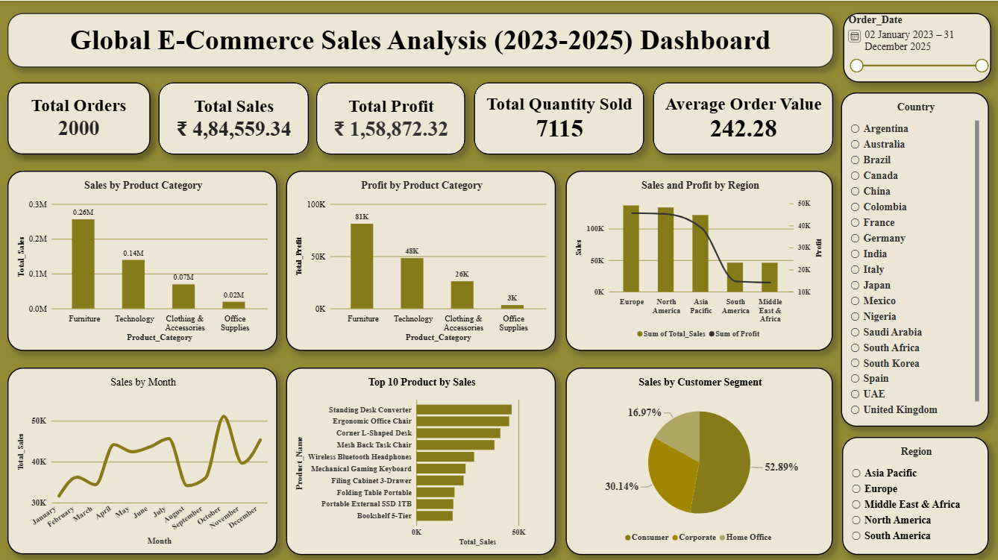

Power BI dashboard showing key sales, profit, product, regional, customer, and monthly sales insights.

Python Analysis
- Loaded the e-commerce dataset using Pandas.
- Checked the dataset structure, number of records, columns, and data types.
- Checked for missing values and duplicate records.
- Calculated total sales, total profit, total quantity sold, and average order value.
- Analyzed sales and profit by product category.
- Identified the top 10 products by sales and profit.
- Analyzed sales and profit by region and customer segment.
- Analyzed payment method usage.
- Analyzed monthly sales trends.
- Studied the relationship between discounts and profit.
- Analyzed shipping costs by region.
- Created charts using Matplotlib to visualize important findings.

Key Insights

- Total sales were ₹4,84,559.34, with a total profit of ₹1,58,872.32.
- Furniture was the highest-selling and highest-profit product category.
- Technology was the second-highest-selling product category.
- Europe generated the highest sales and profit among the regions.
- Mexico generated the highest sales and profit among the countries analyzed.
- The Consumer customer segment contributed the highest sales and profit.
- Standing Desk Converter was the top-selling product by sales.
- Credit Card was the most frequently used payment method.
- Higher discount levels were generally associated with lower total profit.
- Asia Pacific had the highest shipping cost among the regions.
- Monthly sales showed fluctuations with different peaks and declines.

Business Recommendations

- Focus on Furniture and Technology, which generate strong sales and profit.
- Promote high-performing products such as the Standing Desk Converter.
- Monitor discount levels to avoid unnecessary reductions in profit.
- Focus marketing efforts on the Consumer customer segment.
- Strengthen sales strategies in Europe and other high-performing regions.
- Review shipping costs, especially in the Asia Pacific region.
- Encourage convenient payment methods such as Credit Card based on customer usage.
- Monitor monthly sales trends to plan inventory and marketing activities.

Project Conclusion

This project provided a complete analysis of global e-commerce sales data using Excel, MySQL, Power BI, and Python. The analysis helped identify sales and profit performance, top-performing products and categories, customer and regional trends, payment preferences, discount impact, and shipping costs. The Power BI dashboard provides an interactive view of the key business metrics and insights. Overall, the project demonstrates how data analytics tools can be used to convert raw sales data into meaningful business insights for better decision-making.

Project Files

- Global_Ecommerce_Sales_Analysis.xlsx – Excel analysis and pivot tables.
- Global_Ecommerce_Sales_Analysis.sql – MySQL queries and analysis.
- Global_Ecommerce_Sales_Analysis.pbix – Power BI dashboard.
- Global_Ecommerce_Sales_Analysis.ipynb – Python analysis and visualizations.

